Digital Transformation for Entrepreneurial Development in Nepal
Asmita Subedi
Jeebanath Adhikari
Abstract
Rapid development of digital technologies has increasingly revolutionized the entrepreneurial context through improved availability of information, markets, finance, and digital businesses, which has facilitated the scopes of entrepreneurial development. Despite this rapid digital transformation in Nepal, its actual impact on entrepreneurial development remains unclear, as improved digital infrastructure does not automatically translate into new business creation. This study therefore asks: does digital transformation boost new business creation in the short run or over time, and is there a genuine causal link, or are they merely correlated by chance? Annual data of World Development Indicators (WDI) for the period 2006-2024 were used to construct the Digital Transformation Index (DTI) by using Principal Component Analysis (PCA) based on internet usage, number of fixed broadband subscriptions, number of mobile cellular subscriptions, and number of secure internet servers after addressing the multicollinearity issue among the digital transformation variables. The relationship between DTI and New Business Density (NBD) was analyzed using the first-differenced OLS regression model as a main technique of estimation, along with the ARDL bounds testing, Unrestricted Error Correction Model (UECM), and Granger causality tests. The first principal component accounted for 81.9 percent of the variation in the digital transformation variables. The short-run model shows that the DTI positively, but statistically insignificantly, affects NBD, whereas the Granger causality tests show that there is no significant causality in either direction. Although the ARDL bounds test suggested a possible long-run equilibrium relationship, this long-run analysis remains inconclusive due to having only 11 annual observations available after accounting for lags. Overall, the findings suggest that increasing digital infrastructure alone is insufficient to promote entrepreneurship in Nepal which implies that effective policies must also prioritize digital literacy, financial access, institutional quality, and broader entrepreneurial support systems.

Keywords: Digital transformation, entrepreneurial development, New Business Density, Digital Transformation Index, etc.
JEL Classification: L26, O33, O53, C22, L86

- Introduction
In every economic era, entrepreneurship serves as the primary engine of societal transformation (Schumpeter, 1934; Audretsch et al., 2007). It does not always expand national gross domestic product (GDP), it also rewrites the social mobility and redefines how entire generation work approach and value of the creation (van Praag & Versloot, 2007; Aparicio et al., 2016). Entrepreneurship is considered as a key factor in economic growth, job creation, and innovation in both developed and developing economies. Entrepreneurship drive economic growth by commercializing technology and injecting competition among the organization by reallocating capital and labor to high-value uses which raises productivity and GDP (Audretsch et al., 2007; SMEs review, 2024). Entrepreneurship also creates mass employment by scaling up and filling operational gaps in production, logistics, and support which require human capital(OECD, 2025; SMEs review, 2024) and they spearhead innovation by challenging outdated dogmas, investing in R&D, and utilizing rapid prototyping and feedback loops, entrepreneurs yield novel products and efficient processes that diffuse across supply chains to compel incumbent modernization which ultimately raises productivity and living standards. In more recent time, the rapid pace of digitalization has significantly transformed entrepreneurship. Through digital and communication technologies such as, the internet, mobile communication, broadband, and many other online channels, the challenges that entrepreneurs previously faced have slowly eroded, resulting reducing information costs, improving market access and financial inclusion so that the business can reach out to their customers outside its immediate geography (Balsalobre-Lorente et al., 2025; systems review, 2026).
Nepal has witnessed a huge progress in digital adoption ecosystem because of an increase in the number of internet users, mobile users, broadband and digital service (DataReportal, 2024). Some of the efforts taken by the Government of Nepal (GoN) which include the ICT Policy 2015 that set up the basis for ICT development, the National Broadband Policy 2015 that facilitate an affordable access to broadband services, and the Rural Telecommunication Development Fund (RTDF) that helps to develop connectivity in underdeveloped regions (Government of Nepal, 2015; Nepal Telecommunications Authority, 2025). Additionally, there is the Digital Nepal Framework (DNF) 2019 that provides the national strategy of utilization of digital technologies in various sectors, such as education, healthcare, agriculture, governance, tourism, and finance. In accordance with recent statistics, Nepal currently has approximately 16.5 million internet users that are 55.8 percent of its population, and 39 million mobile cellular connections that are 132 percent of its population. Thus, the adoption of digital payment ecosystems initiated by Nepal Rastra Bank (NRB), as well as the proliferation of e-governance services, like Nagarik App, online government services, and digital marketplaces, is evidence of the development of Nepal towards the digital economy (Nepal Rastra Bank, 2023; Department of Information Technology, 2026).
Despite of these progress, Nepal faces a unique set of challenges. Limited infrastructure in rural areas, low digital Literacy and entrepreneurial Skills, limited access to finance for digital investment and weak policy implementation and digital ecosystem. Furthermore, instability in economic growth, low domestic credit availability, fluctuations in foreign direct investments, cybersecurity and trust issues, and a lack of skilled human resources pose significant obstacles for achieving sustainable digital transformation. Despite these challenges, the digitalization of Nepal presents a transformative opportunity to address long-standing issues such as inefficiency, corruption, and inaccessibility in public services. (APNIC Blog, 2025; Rising Nepal Daily, 2025; The Diplomat, 2026; World Bank, 2018; The Himalayan Times, 2025; World Economic Forum, 2025; The Annapurna Express, 2025; Spotlight Nepal, 2026; Nepal Journals Online, 2025; World Bank, 2025; East Asia Forum, 2026; IMF, 2026; Kantipur Daily, 2025).
Small enterprises increasingly use digital technologies. They use them for advertising, transactions, to serve customers and these customers are no longer local, now they reach buyers beyond their immediate vicinity. This trend is becoming more common. In this way, local businesses merge with broader regional and global markets. Current literature on Nepal also highlights this trend, with digital literacy and access to digital finance being linked to greater intention to be entrepreneurial and development of microenterprises (Pandey & Taufique, 2022; Shrestha & Neupane, 2020). However, NBD reflects that there is reason to believe that different groups of the population may not experience such effects equally and future research must determine whether digital transformation has a measurable impact on entrepreneurial development.
This study addresses gap by analyzing the effect of digital transformation on entrepreneurial development in Nepal
The primary objective of this research is to analyze the relationship between digital transformation and entrepreneurship development in Nepal. Based on these theoretical and empirical arguments, the authors propose the hypothesis of the long-run impacts of digital transformation on entrepreneurial development and moderation effect of macroeconomic variables on the relationship between digital transformation and entrepreneurial development.

2. Review of Literature
Digitalization has generated considerable policy interest where relatively few empirical studies have examined that analyze the impact of digitalization on entrepreneurship development in Nepal through a time-series econometric approach. Most of the existing literature available are descriptive and/or comparative across countries. In addition, most of the literatures have analyzed the impact of individual indicators of ICT without considering their collective impact.
According to the Knowledge Spillover Theory of Entrepreneurship (KSTE), both knowledge and innovation act as sources of entrepreneurship and economic growth (Acs et al., 2012). In the same way, the use of digital technology allows entrepreneurs to identify opportunities, where they can be more productive, take benefits from financial services and innovations in their firms (Goldfarb & Tucker, 2019; Autio et al., 2018). Research provides empirical evidence in support of this by showing how the development of ICTs such as internet, mobile telephony, and broadband relates to productivity and firm activity. The significance becomes increasingly prominent for developing countries in which Countries can use digitalization to address structural issues such as lack of market access, poor financial services, and fragile institutions Through creating access to information, finance, and markets, digital technologies enable economic activities that were not possible before (Aker & Mbiti, 2010). Financial access is particularly important for the success of entrepreneurship, especially for SMEs, which play an important role in economic development (Beck et al., 2018; Brixiová et al., 2020).
Digital transformation has radically changed the ways how the businesses are started, run, and grown in modern times. This makes digital transformation one of the main factors contributing to entrepreneurial growth. Increased use of digital technology has slowly started to break down many of the barriers that have existed traditionally for entrepreneurial success. These include lack of access to information, markets, finance, and business networking facilities. Using digital technology, entrepreneurs are able to get information about the market environment easily, communicate with customers in a less costly manner, transact over the Internet, and gain access to wider domestic and international markets. The theoretical relationship between digital transformation and entrepreneurship from a theoretical perspective can be explained by means of the KSTE. This theory demonstrates how the creation of knowledge and innovations creates entrepreneurial opportunities that help to achieve economic development (Acs et al., 2012). Digital technologies assist in this process by accelerating the process of knowledge creation, distribution, and application to allow entrepreneurs to find opportunities, create innovations, and enhance-businesses performance (Autio et al., 2018; Nambisan, 2017). Consequently, digital transformation serves as an important mechanism through which knowledge spillovers are converted into entrepreneurial activities and economic growth. In previous research, various mechanisms were found whereby digital transformation can enhance entrepreneurship. Digital platforms help firms access customers located outside their geographical locations, thus widening the markets (World Bank, 2016). Communication technology and digital financial services make it easy for firms to access financial assets and minimize transaction costs, especially in poor nations where financial assets are often limited (Aker & Mbiti, 2010). Likewise, digital technologies enhance communication, efficiency, innovations, and competitiveness in business. There exist positive correlations between ICT adoption and firm productivity and organizational effectiveness (Cardona et al., 2013), while digitalization helps firms to innovate new business models and create new value propositions (Ritter & Pedersen, 2020). Based on the above theory, digital transformation is expected to foster entrepreneurship through knowledge, market, financial, and business opportunities access.
Digital transformation is a multidimensional phenomenon that involves various complementary digital technologies. Internet usage, mobile communications, broadband connectivity, information and communication technology development, and digital infrastructure have been widely used as measures of digital transformation, each representing a different dimension relevant to entrepreneurial activity. Information is the assets. The use of the internet enables entrepreneurs to gather information about their business, interact with their customers and suppliers, conduct business on digital platforms, and utilize digital business services which generally evolves the business. Broadband connections provide fast internet connection and allow businesses to use digital platforms, cloud computing, e-commerce, and other technology-intensive operations. Mobile cellular subscriptions facilitate communicating with others and have been crucial in fostering mobile banking and digital payments in developing nations (Aker & Mbiti, 2010). ICT service exports indicate the digital competence and technological capabilities of an economy and also creates knowledge spillovers that could stimulate entrepreneurship (Autio et al., 2018). Secure internet servers denote the security and reliability of digital infrastructure which are important for conducting online business. These five indicators collectively represent various dimensions of digital transformation. Nonetheless, due to their high level of correlation, their simultaneous use in the regression could result in multicollinearity and make the estimated coefficients difficult to interpret. For this reason, this study combines these five measures into an DTI, thus allowing for measurement of digital transformation as a whole without any problem of multicollinearity.
Though digital transformation is believed to facilitate entrepreneurship, its effectiveness may depend upon the wider macroeconomic environment. Economic conditions influence the amount of money available, investment possibilities, market demands, and institutions that affect the entrepreneurship. Economic growth creates a positive environment for the establishment of new businesses and opportunities through higher business opportunities and demand from consumers. Similarly, increased availability of financial resources can be used to expand and innovate businesses. It has been demonstrated in earlier studies that financial development is a significant factor in explaining entrepreneurial activities because they reduce borrowing constraints for small and medium enterprises (Beck et al., 2018; Brixiová et al., 2020). Hence, digitalization could have a greater impact on entrepreneurial activities when the economy is stable than when it is unstable. The relationship between digital transformation and entrepreneurship development may not occur immediately. The adoption of technologies like the digital infrastructure investments, the Internet, and digital skills could take time before their effect is seen on entrepreneurship. Thus, the connection may be different in the short-run and the long-run. Non-stationary characteristics are common in time series such as the digital transformation and entrepreneurial development process. Therefore, it is quite important to differentiate between the short-run adjustment process and the long-run equilibrium process. The ARDL approach introduced by Pesaran et al. (2001) provides an appropriate framework for estimating short-run dynamics and the long-run relationship among variables that are integrated of different orders, provided that none is integrated of order two.
3. Data and Methodology
3.1 Data
The empirical analysis comprises 19 annual observations from the World Bank's WDI and Entrepreneurship Database (World Bank, 2022). This time span was chosen based on data availability for all variables of interest
through the use of annual time series data for the period 2010 to 2023.
Table 1: Variables definition and sources
Variable | Definition | Source
Dependent variable
NBD | New business density which is new business registrations per 1,000 people ages 15–64 | World Bank
Independent variables (Digital Transformation)
Internet | Individuals using the internet (% of population) | World Bank
Broadband | Fixed broadband subscriptions (per 100 people) | World Bank
Mobile | Mobile cellular subscriptions (per 100 people) | World Bank
ICT_Exports | ICT goods exports (% of total goods exports) | World Bank
Secure_Servers | Secure internet servers (per 1 million people) | World Bank
DTI | Digital Transformation Index/ PCA based composite index is constructed from internet, broadband, mobile, and secure_servers. | calculation
Control variables
GDP_Growth | GDP per capita growth (annual %) | World Bank
Domestic_Credit | Domestic credit to the private sector (% of GDP) | World Bank
FDI | Foreign direct investment, net inflows (% of GDP) | World Bank
Pop_Density | Population density (people per sq. km of land area) | World Bank
School_Enroll | School enrollment, tertiary (% gross) | World Bank
Urban_Pop | Urban population (% of total population) | World Bank

This research uses NBD as the indicator of entrepreneurial development, while internet usage, mobile cellular subscriptions, broadband internet subscriptions, ICT services export, and secure internet servers are representing the dimensions of digital transformation. Additionally, the study takes into account selected macroeconomic variables to analyze whether economic factors amplify or mitigate the relationships between digital transformation and entrepreneurship. The study uses advanced econometric models such as ARDL Autoregressive Distributed Lag (ARDL) model, moderation analysis, nonlinear analysis, diagnostic tests and other econometric techniques, including Granger causality to establish the associations in both the short run and the long run.
The dependent variable is NBD and that employed or allowed for cross-country comparisons and captures entrepreneurial dynamism. As the main independent variable, the authors construct a DTI using PCA to capture the multi-dimensional nature of digital transformation in Nepal. The DTI was derived from four digital infrastructure and adoption indicators: internet penetration, fixed broadband subscriptions, mobile cellular subscriptions, and secure internet servers.

3.2 Methodology
3.2.1 Stationarity Analysis
To determine the order of integration of each variable, we employ three complementary unit root and stationarity tests first one is Augmented Dickey-Fuller (ADF) test which provides H₀: unit root (non-stationary) secondly, Phillips-Perron (PP) test which gives H₀: unit root (non-stationary) and KPSS test for H₀: stationary. These three tests are used together because ADF and PP (null hypothesis of unit root) can disagree with KPSS (null hypothesis of stationarity) in small samples. Running all three provides a more reliable read on the order of integration than any single test.
3.2.2 Principal Component Analysis
Due to severe multicollinearity among the digital transformation indicators, we construct a composite index using PCA:
$$DTI_{i}= \sum_{j=1}^{k}{w_{j}Z_{ij}}$$
Where, $D TI_{i}$ is DTI for observation i where, $Z_{ij}$ is Standardized value of digital transformation indicator j for observation i and $w_{j}$ represents Loading (weight) of digital transformation indicator j obtained from the first principal component. Here, k is the number of digital transformation indicators included in the PCA. in this study, k = 4 so it is calculated as:
$$DTI_{i}= w_{1}Z_{Internet,i}+ w_{2}Z_{Broadband,i}+ w_{3}Z_{Mobile,i}+ w_{4}Z_{SecureServers,i}$$
3.2.3. Short-Run Growth Model
Although the bivariate ARDL bounds test indicates cointegration (Pesaran et al., 2001). The small sample size limits the reliability of the long-run estimates. Therefore, the first-differenced model is treated as the primary specification, while the ARDL results are presented as exploratory evidence so, we estimate the short-run relationship directly on first-differenced data as:
$$ΔNBD_{t}=β_{0}+β_{1ΔDTI_{t}}+ε_{t}$$
where,$ΔNBD_{t}$ is First difference of NBD at time t,$ΔDTI_{t}$ is First difference of the Digital Transformation Index at time t and β0​ is Intercept , β1​ represents Short-run effect of digital transformation on entrepreneurship development and ​$ε_{t}$ is the Error term.
3.2.4 ARDL Bounds Testing
To explore long-run dynamics, we estimate an ARDL(1,1) model:
$$NBD_{t}=α+β_{1NBD_{\left\{t-1\right\}}}+β_{2DTI_{t}}+β_{3DTI_{\left\{t-1\right\}}}+ε_{t}$$
Where,$NBD_{t}$ represents New Business Density at time t,$NBD_{t-1}$ represents One-period lag of New Business Density,$DTI_{t}$represents DTI at time t,$DTI_{t-1}$ represents One-period lag of the Digital Transformation Index ,α is Constant term ,β1,β2,β3 is Estimated coefficient and εt​ is Error term.
Cointegration is assessed using the ARDL bounds testing approach (Pesaran et al., 2001). The F-statistic is compared against critical bounds: if it exceeds the upper bound, we reject the null hypothesis of no cointegration. However, given the small sample (n=11), the long-run coefficients are reported as indicative and should be interpreted with caution, with the first-differenced model serving as the primary result.
3.2.5 Granger Causality Testing
To investigate the direction of causality between digital transformation and entrepreneurship, we employ Granger causality tests on first-differenced series to satisfy stationarity:
Yt= α + i=1pβiYt-iβiYt-i+ i=1pγiXt-i+ εtγiXt-i+ εt

Because the sample size is small, one lag (p = 1) is used. The estimated model is:
Yₜ = α + β₁Yₜ₋₁ + γ₁Xₜ₋₁ + εₜ
Where,Yₜ is dependent variable at time t,Yₜ₋₁ = one-period lag of the dependent variable,Xₜ₋₁ = one-period lag of the independent variable, α = intercept (constant term), β₁ = coefficient of the lagged dependent variable, γ₁ = coefficient of the lagged independent variable and εₜ = error term at time t.
4. Results
4.1 Descriptive Statistics
In the data set, four missing values for NBD and secure internet servers were observed, one each for population density and school enrolment, while no missing values observed in the rest of the variables.
Table 2:Descriptive Statistics of the Study Variables
Variable | Obs. | Mean | Std. Dev. | Min | 25% | Median | 75% | Max | Missing | Skewness
NBD | 15 | 0.781 | 0.320 | 0.369 | 0.580 | 0.630 | 1.003 | 1.398 | 4 | 0.894
Internet | 19 | 21.217 | 16.252 | 1.141 | 8.465 | 17.582 | 35.151 | 46.322 | 0 | 0.325
Broadband | 19 | 2.720 | 3.450 | 0.004 | 0.282 | 1.088 | 3.969 | 10.675 | 0 | 1.466
Mobile | 19 | 82.872 | 47.560 | 4.356 | 41.128 | 98.895 | 124.989 | 139.526 | 0 | -0.441
ICT Exports | 19 | 14.492 | 7.794 | 5.551 | 8.039 | 11.464 | 21.005 | 30.034 | 0 | 0.679
Secure Servers | 15 | 172.447 | 207.079 | 0.878 | 3.220 | 156.080 | 240.119 | 642.608 | 4 | 1.193
GDP Growth | 19 | 4.278 | 2.533 | -2.370 | 3.417 | 4.533 | 5.821 | 8.977 | 0 | -0.751
Domestic Credit | 19 | 66.136 | 20.746 | 33.151 | 51.057 | 59.178 | 83.693 | 103.651 | 0 | 0.266
FDI | 19 | 0.296 | 0.206 | -0.074 | 0.147 | 0.298 | 0.434 | 0.677 | 0 | 0.042
Population Density | 19 | 195.038 | 6.671 | 185.319 | 190.949 | 193.568 | 197.631 | 207.293 | 0 | 0.685
School Enrollment | 18 | 67.852 | 15.968 | 42.097 | 56.440 | 68.072 | 83.012 | 90.388 | 1 | -0.196
Urban Population | 19 | 62.982 | 4.809 | 49.506 | 62.578 | 64.951 | 66.046 | 66.772 | 0 | -1.839

Table 1 presents the descriptive statistics of the study variables for Nepal over the 2006–2024 period. The number of observations ranges from 15 to 19, indicating the presence of a few missing values. The study variables exhibit moderate variation across the sample period and The digital transformation indicators also display noticeable variation over time. The skewness statistics indicate that most variables are moderately skewed, whereas Broadband, Secure Internet Servers, and Urban Population exhibit relatively higher levels of skewness.
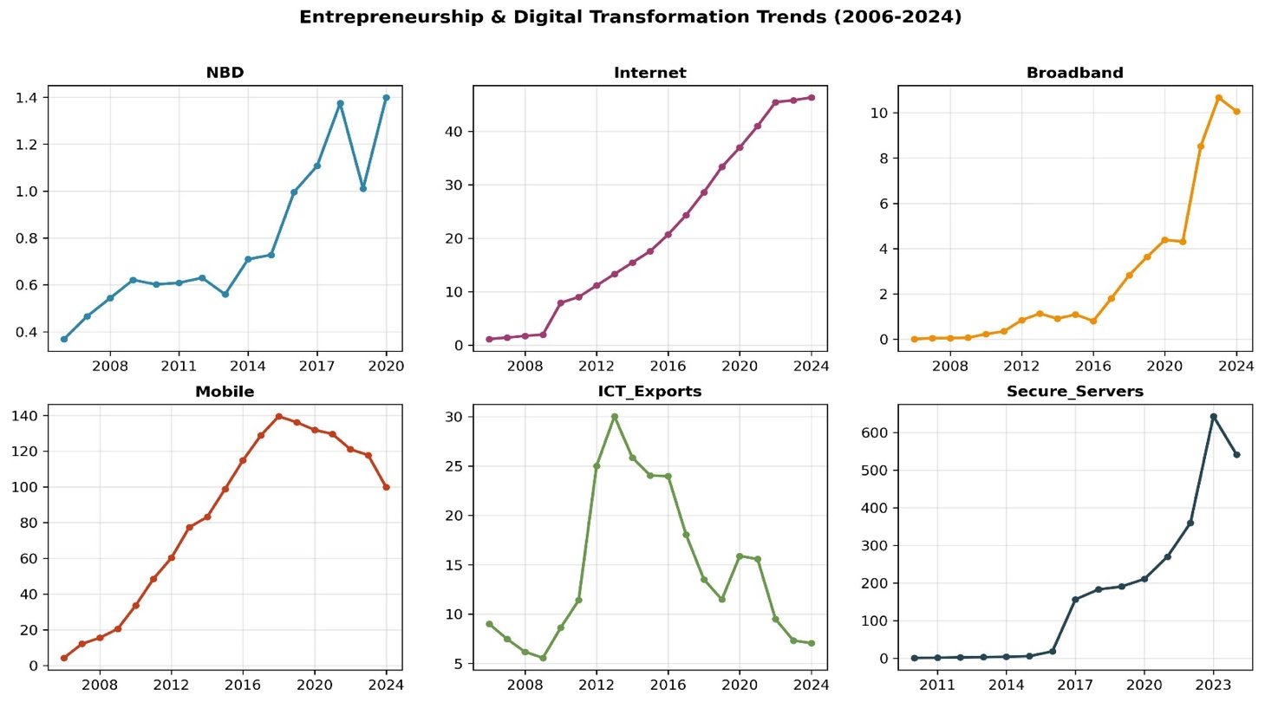
Figure 1: Trends in entrepreneurship and digital transformation indicators in Nepal over the period 2006–2024.
Figure 1 illustrates the trends in entrepreneurship and digital transformation indicators in Nepal over the period 2006–2024. The figure shows changes in NBD and five digital transformation indicators throughout the study period. NBD exhibits an overall upward trend from 2006 to 2024. It increases gradually from approximately 0.37 in 2006 to 1.40 in 2024.Though there is a fall in NBD in 2023, the next year witnesses an increase. Overall, the upward trend indicates that there is an improvement in business creation over the study period trend in internet Users in Nepal from 2006 to 2024 shows a steady increase in the number of internet users, rising from 1.1% of the population in 2006 to 46.3 percent in 2024. Internet usage increased gradually during the early years of the study period and then increases rapidly after 2016 reflecting the rapid expansion of internet access and adoption in Nepal.
the trend in Fixed Broadband Subscriptions remained very low between 2006 and 2011, began to increase steadily from 2012 onward. The growth rate accelerated after 2021 until it peaked at about 10.7 subscriptions per 100 people in 2023, before declining slightly in 2024. Overall, the figure indicates substantial growth in broadband adoption and digital infrastructure which may reflect , the expansion of fiber-optic networks, increased demand for high-speed internet, and continued investment in digital infrastructure.
Mobile subscriptions exhibited a strong upward trend, increasing from around 4.4 subscriptions per 100 people in 2006 to an all-time high of about 139.5 subscriptions per 100 people in 2018. After 2018, there was a gradual decline in mobile subscriptions to approximately 100 subscriptions per 100 people in 2024. The decline after the peak may reflect market saturation, reduced use of multiple SIM cards, and the consolidation of mobile subscriptions. Whereas the trend in the ICT Service exhibited a fluctuating trend throughout the study period. Their share declined slightly between 2006 and 2009 followed by a sharp increase and rea that reached a peak of about 30.0 percent in 2013. After 2013, the ICT service exports showed a general downward trend, except for a slight recovery period between 2020 and 2021. By 2024, ICT service exports had declined to approximately 7.2%.
The number of secure internet servers remained very low from 2010 to 2016, after which it increased sharply from 2017 onward. This upward trend was maintained throughout the study period reaching a peak of approximately 643 in the year 2023, before declining slightly to approximately 543 in 2024. The sudden growing use of online communication could be attributed to investment in digital infrastructure, greater adoption of secure online services, or expansion of digital and e-commerce services.
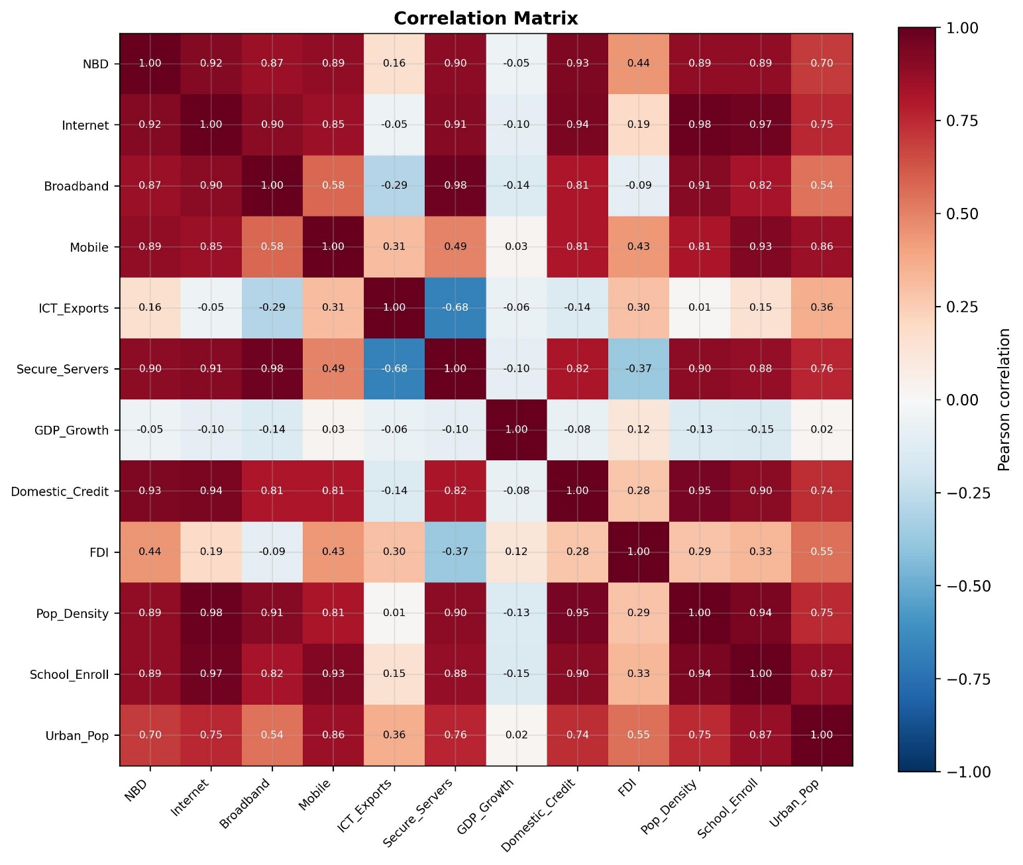
Figure 2: The Pearson correlation matrix for the study variables
Figure 2 represents the Pearson correlation matrix for the study variables in Nepal over the 2006–2024 period. The results revealed that NBD strongly correlates positively with internet users (r = 0.92), broadband subscriptions (r = 0.87), mobile subscriptions (r = 0.89), secure internet servers (r = 0.90), domestic credit (r = 0.93), population density (r = 0.89), school enrollment (r = 0.89), and urban population (r = 0.70). On the other hand, GDP Growth (r = -0.05) is very weakly negatively associated with NBD; while ICT Service Exports (r = 0.16) and FDI (r = 0.44) are positively correlated with it. Overall, the correlation matrix indicates a high positive correlation between entrepreneurial development and most of the digital transformation indicators while no presence of perfect multicollinearity is evident among the explanatory variables.
4.2 Unit Root Tests
Table 3 : Unit Test Result
Variable | Transformation | ADF Statistic | ADF p-value | PP Statistic | PP p-value | KPSS Statistic | KPSS p-value | Conclusion
NBD | Level | -2.848 | 0.052 | 0.167 | 0.970 | 0.762 | 0.010 | Non-Stationary
NBD | First Difference | -1.295 | 0.631 | -7.811 | 0.000 | 0.500 | 0.042 | Mixed Evidence
Internet | Level | 1.369 | 0.997 | 0.898 | 0.993 | 0.714 | 0.012 | Non-Stationary
Internet | First Difference | -1.493 | 0.537 | -3.007 | 0.034 | 0.260 | 0.100 | Mixed Evidence
Broadband | Level | 2.483 | 0.999 | 1.779 | 0.998 | 0.609 | 0.022 | Non-Stationary
Broadband | First Difference | -0.859 | 0.801 | -3.080 | 0.028 | 0.359 | 0.095 | Mixed Evidence
Mobile | Level | -5.372 | 0.000 | -1.768 | 0.396 | 0.628 | 0.020 | Mixed Evidence
Mobile | First Difference | -1.844 | 0.359 | -0.486 | 0.895 | 0.597 | 0.023 | Non-Stationary
ICT Exports | Level | -1.164 | 0.689 | -1.245 | 0.654 | 0.160 | 0.100 | Mixed Evidence
ICT Exports | First Difference | -2.921 | 0.043 | -2.376 | 0.149 | 0.204 | 0.100 | Mixed Evidence
Secure Servers | Level | 1.685 | 0.998 | 0.768 | 0.991 | 0.544 | 0.032 | Non-Stationary
Secure Servers | First Difference | -3.957 | 0.002 | -3.699 | 0.004 | 0.224 | 0.100 | Stationary
GDP Growth | Level | -8.150 | 0.000 | -6.288 | 0.000 | 0.063 | 0.100 | Stationary
GDP Growth | First Difference | -29.375 | 0.000 | -12.338 | 0.000 | 0.299 | 0.100 | Stationary
Domestic Credit | Level | -1.127 | 0.704 | -1.093 | 0.718 | 0.679 | 0.015 | Non-Stationary
Domestic Credit | First Difference | -3.491 | 0.008 | -3.669 | 0.005 | 0.087 | 0.100 | Stationary
FDI | Level | -3.113 | 0.026 | -3.233 | 0.018 | 0.216 | 0.100 | Stationary
FDI | First Difference | -5.776 | 0.000 | -6.714 | 0.000 | 0.363 | 0.093 | Stationary

Note: ADF and PP tests have the null hypothesis of a unit root (non-stationarity), whereas the KPSS test has the null hypothesis of stationarity. The 5% critical value for the KPSS test is 0.463 for all variable.

Table 3 presents the results of the Augmented Dickey–Fuller (ADF), Phillips–Perron (PP), and KPSS unit root tests for the study variables. The results indicate that GDP Growth and FDI are stationary at level, while Secure internet servers and domestic credit are stationary after applying first difference. The variables NBD, internet, broadband, mobile and ICT services export have mixed result for stationarity through three tests, while other variables are non-stationary at level. Overall, the findings indicate that the dataset contains a combination of I(0) and I(1) variables. Therefore, model is appropriate for the empirical analysis.
4.3 Multicollinearity test
Table 4: Multicollinearity test results
Variable | VIF | Interpretation
Internet | 251.25 | Severe multicollinearity
Broadband | 162.19 | Severe multicollinearity
Mobile | 14.43 | Severe multicollinearity
ICT Exports | 2.69 | Acceptable
Secure Servers | 45.79 | Severe multicollinearity
GDP Growth | 1.24 | Acceptable
Domestic Credit | 56.50 | Severe multicollinearity
FDI | 2.43 | Acceptable

Table 4 presents the Variance Inflation Factor (VIF) results for the explanatory variables. From the findings, it is evident that there are some cases of severe multicollinearity within some of the digital transformation variables. Specifically, internet (VIF= 251.25), broadband (VIF = 162.19), secure internet servers (VIF = 45.79), domestic credit (VIF = 56.50), and mobile (VIF = 14.43) have very high VIF values, which exceed the threshold of 10, this indicates severe multicollinearity. However, ICT Services Exports (VIF = 2.69), GDP Growth (VIF = 1.24) and FDI (VIF = 2.43) have acceptable VIF values, suggesting no multicollinearity concerns. Hence, the presence of severe multicollinearity in the digital transformation indicators makes it appropriate to consider using a composite DTI in place of these highly correlated indicators in the regression analysis.
VIF readings for internet, Broadband, and secure_servers are quite high at values greater than 10 which indicates of strong multicollinearity. Indeed, it is logical to expect that internet connectivity, broadband, and secure servers in Nepal will follow the same pattern of digitalization over 2006-2024. Instead of running separate tests for each dimension or including all three dimensions in one regression model, they are merged using PCA.
4.4 Digital Transformation Index (PCA) test:

Table 5 : Digital Transformation Index (PCA) test results
Component | Explained Variance Ratio | Cumulative Variance (%) | Internet | Broadband | Mobile | Secure Servers
PC1 | 0.819 | 81.9 | 0.545 | 0.521 | 0.393 | 0.526
PC2 | 0.167 | 98.6 | 0.073 | -0.389 | 0.857 | -0.331
PC3 | 0.010 | 99.6 | 0.695 | 0.131 | -0.255 | -0.659
PC4 | 0.004 | 100.0 | -0.463 | 0.748 | 0.216 | -0.423
Note: This study uses PC1 to construct PCA

Table 5 presents the results obtained for the analysis through PCA conducted to construct the DTI using four digital transformation indicators internet Users, fixed broadband subscriptions, mobile cellular subscriptions, and secure internet servers. The first principal component (PC1) explains 81.9% of the total variance, indicating that it captures most of the information about the four variables. Thus, PC1 was chosen as DTI. The remaining principal components explain is only 16.7%, 1.0%, and 0.4%, respectively, meaning that the other components contribute relatively little additional information. The component loadings show, all four variables have positive loadings in PC1 (internet = 0.545, broadband = 0.521, mobile = 0.393, and secure internet servers = 0.526). This means that all the indicators positively contribute to the composite index. Since higher values for all four indicators represent a greater level of digital transformation a higher DTI score indicates a greater digital transformation in Nepal.

4.5 Stationarity Test Interpretation

Table 6: Unit Root Test Results for the DTI
Variable | Transformation | ADF Statistic | ADF p-value | PP Statistic | PP p-value | KPSS Statistic | KPSS p-value | Conclusion
DTI | Level | 0.967 | 0.994 | 0.292 | 0.977 | 0.596 | 0.023 | Non-Stationary
DTI | First Difference | -2.949 | 0.040 | -2.302 | 0.171 | 0.087 | 0.100 | Mixed Evidence
Note: ADF and PP tests have the null hypothesis of a unit root (non-stationarity), whereas the KPSS test has the null hypothesis of stationarity. The 5% KPSS critical value is 0.463.

Table 6 results show mixed evidence regarding the stationarity of DTI after first differencing, but the majority of findings indicate that DTI is integrated of order one [I(1)]. It presents the results of the ADF, PP and KPSS unit root test of the DTI. In this case, the results indicate that DTI is non-stationary at level, as both ADF and PP tests fail to reject the null hypothesis of a unit root, while KPSS test rejects the null hypothesis of stationarity (KPSS statistic = 0.596, p-value = 0.023 After first differencing, ADF test indicates that DTI is stationary (p-value = 0.040) while PP test remains statistically insignificant (p-value = 0.171). The KPSS test statistic (KPSS statistic = 0.087, p-value = 0.100) does not reject the null hypothesis of stationarity suggesting that DTI is stationary after first differencing.
4.6 Main Model (First-Differenced Short-Run Growth Model)
Short run model presents the results of the OLS regression analysis conducted to examine the short-run impact of changes in the Digital Transformation Index (ΔDTI) on changes in New Business Density (ΔNBD). The coefficient of ΔDTI is 0.1115, indicating that a one-unit increase in the DTI is associated with a 0.1115-unit increase in NBD. However, this relationship is not statistically significant (p = 0.480), implying that the short-run changes in digital transformation do not have a significant effect on short-term entrepreneurial growth in Nepal. The regression model explains only just 1.0% of the variance in NBD (R² = 0.010), indicating very weak explanatory power. Moreover, the entire regression model is statistically insignificant (F = 0.499, p = 0.500), indicating that the independent variable does not play a significant role in the changes in entrepreneurial activity. Overall, it can be seen that there is no significant relationship between the changes in the DTI and the changes in NBD in the short run.
$$ΔNBDₜ = 0.0404 + 0.1115ΔDTIₜ + εₜ$$
Where, β₀ = 0.0404 is a constant/intercept, β₁ = 0.1115 is short-run effect of DTI on NBD, and εₜ is error term.
Although, the estimated coefficient is positive, there is no statistically significant relationship between short-run changes in digital transformation and changes in entrepreneurial activity in Nepal during the period under analysis. One possible explanation is that the impacts of digital transformation on entrepreneurship can take longer to be realized or need other economic considerations.
4.7 ARDL Estimation Results
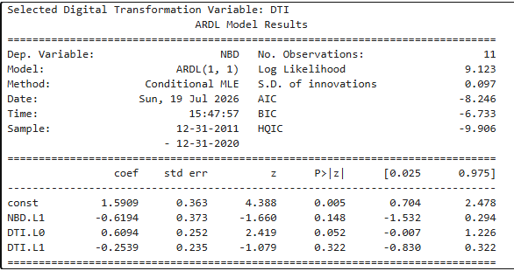
Figure 3: ARDL Estimation Results
Fig. 10 shows the estimation results of the ARDL(1,1) model to investigate the relationship between the DTI and NBD in Nepal. The ARDL estimation result can be formulated as:
$NBDₜ = 1.5909 - 0.6194NBDₜ^{-1}+ 0.6094DTIₜ - 0.2539DTIₜ^{-1}+ εₜ$
Where, 1.5909 is the estimated intercept (constant term), −0.6194 is the estimated coefficient of the one-period lag of New Business Density , 0.6094 is the estimated coefficient of the current Digital Transformation Index, −0.2539 is the estimated coefficient of the one-period lag of the DTI and εt​ is the error term .
The coefficient of the DTI in the same period is estimated to be 0.6094, implying that a unit increase in the DTI causes a 0.6094 increase in New Business Density, other things being equal. However, the coefficient is only marginally significant at the 5% significance level (p=0.052) but significant at the 10% significance level, implying weak evidence for positive short-run relationship between digital transformation and entrepreneurial development.
Coefficient for the lagged Digital Transformation Index (DTIₜ₋₁) is -0.2539, which is statistically insignificant (p-value = 0.322). This means that the level of digital transformation in the previous year does not have any significant effect on the current level of entrepreneurial growth. In the same manner, the coefficient for the lagged dependent variable, NBDₜ₋₁ is -0.6194, which is statistically insignificant (p-value = 0.148).
The overall ARDL analysis results show that there is a positive contemporaneous relationship between digital transformation and entrepreneurial development. nonetheless, the effect is insignificant and there are no lagged significant effects either. These results imply that improvements in digital transformation can help entrepreneurship in the contemporary period, though the results are not robust enough and are insignificant at the conventional 5% significance level. It is also important to note that the results should be the results should be interpreted with caution because the ARDL approach is estimated on only 11 annual observations which may limit the statistical power and reliability of estimates.
4.8 ARDL Bounds Test

Table 7 :ARDL Bounds Test Results
Test Statistic | Value
F-statistic | 9.692
Lower Bound, I(0) (5%) | 3.802
Upper Bound, I(1) (5%) | 4.812
Decision | Cointegration Exists

Table 7 presents the results of the ARDL Bounds Test examining the relationship between the DTI and NBD. The computed F-statistic for this test is 9.692, which is greater than the upper critical bound of 4.812 at the 5% significance level. Therefore, the null hypothesis of no cointegration is rejected, indicating the existence of a long-run equilibrium relationship between digital transformation and entrepreneurial development in Nepal. In addition, the upper and lower bound p-values also confirm this. However, since the ARDL model is estimated using 11 years of data, the long-run relationship should be interpreted with caution. Therefore, the long-run estimates obtained from the Error Correction Model (UECM) are considered as merely illustrative while the estimates derived through first-differenced OLS model are considered the primary findings of this study.

4.9 Short-Run and Long-Run UECM Results

Table 8: Short-Run and Long-Run UECM Results
Variable | Coefficient | Std. Error | t-Statistic | p-value
Short-Run Coefficients
ΔDTI (short-run) | 0.609432 | 0.251922 | 2.419131 | 0.051924
Error Correction Model (ECM) / Long-Run Coefficients
Constant | 1.590870 | 0.362522 | 4.388343 | 0.004626
ECT (NBD.L1) | -1.619355 | 0.373071 | -4.340608 | 0.004872
DTI | 0.355494 | 0.084367 | 4.213656 | 0.005600

Table 8 presents the short-run and long-run coefficients that estimated from the UECM model. The short-run coefficient of ΔDTI is 0.6094, which means that a one-unit increase in the Index is associated with NBD will be increased by 0.609 units. However, the coefficient is not statistically significant at 5% significance level (p = 0.052), yet it is statistically significant 10% significance level. This implies that there is weak evidence for the short run impact of digital transformation on entrepreneurship development.
ΔNBDₜ = 1.5909 − 1.6194NBDₜ₋₁ + 0.3555DTIₜ₋₁ + 0.6094ΔDTIₜ + εₜ
The long-run results show that the value of the error correction term (ECT), given by the coefficient of NBD.L1, is −1.6194 and statistically significant (p=0.005). The negative and statistically significant ECT shows that there is a long-run equilibrium relationship between the DTI and NBD. It also suggests that any deviation from the long-term equilibrium is corrected over time, with a relatively rapid rate of adjustment. The long-term coefficient of DTI is 0.3555 and statistically significant at p=0.006, implying that higher levels of digital transformation are associated with entrepreneurial development in the long run. But due to the fact that the estimates are made on the basis of only 11 annual observations, they must be treated cautiously and regarded as illustrative rather than conclusive, as suggested in the study.
4.6 Granger Causality

Table 9: Granger Causality Test Results
Direction | Lag | F-Statistic | p-value | Decision
DTI → NBD | 1 | 0.307 | 0.5994 | Fail to Reject H₀
NBD → DTI | 1 | 2.092 | 0.1982 | Fail to Reject H₀

Note: H₀: The independent variable does not Granger-cause the dependent variable.

The findings of the Granger causality test examining the directional relationship between DTI and NBD are provided by above table. Table shows there is no Granger causality from DTI to NBD because the calculated F-statistic equals 0.307 and the p-value (0.599) exceeds the 5% significance level. Similarly, NBD does not The results indicate that Granger-cause DTI with an F-statistic value of 2.092 and a p-value of 0.198. Hence, the null hypothesis of no Granger causality cannot be rejected in both cases. The results obtained show that there is no statistical evidence of a causal relationship between digital transformation and entrepreneurial development in Nepal.
According to the Granger causality test, there is no evidence of causality either direction between the DTI and NBD during the period of the study. This implies that changes in digital transformation do not significantly predict future changes in entrepreneurial development, and vice versa. However, these results should be interpreted with caution since this particular study was conducted on a small sample size using only a one-lag specification
4.7 Diagnostics

Table 10 : Diagnostic Test Results for the estimated ARDL model
Diagnostic Test | Test Statistic | p-value | Decision | Interpretation
Breusch–Godfrey Test | 2.759 | 0.2517 | Pass | No serial correlation
Jarque–Bera Test | 0.551 | 0.7591 | Pass | Residuals are normally distributed
Breusch–Pagan Test | 0.997 | 0.8019 | Pass | Homoskedastic residuals
Ramsey RESET Test | 0.956 | 0.3731 | Pass | Model is correctly specified

The diagnostic test values of the estimated ARDL model are presented in the above table. The Breusch-Godfrey test yielded a p-value of 0.252, which implies that null hypothesis of no serial correlation cannot be rejected. Hence, the residuals of the model are do not exhibit autocorrelation. According to the Jarque-Bera test, p=0.759 which means that residuals are normally distributed. The Breusch-Pagan test was used in order to detect heteroskedasticity, p=0.802 which means that the null hypothesis of homoskedasticity cannot be rejected and residuals have constant variance. Finally, the Ramsey RESET test returned a value of p=0.373, suggesting that the model is properly specified and there is no evidence of omitted explanatory variables. In general, the diagnostic test results indicate that the estimated ARDL model satisfies the key econometric assumptions, meaning that the estimated ARDL model meets all the main econometric assumptions.
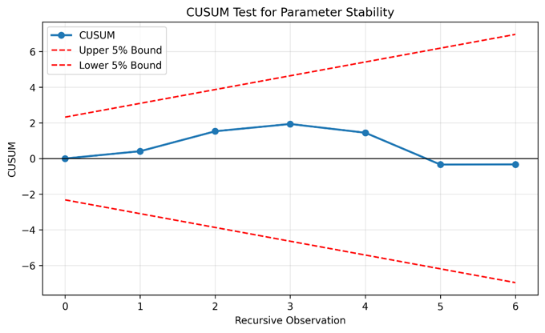
Figure 3: CUSUM Test for Parameter Stability
Figure 3 presents the results of the CUSUM test for parameter stability of the estimated ARDL model. The CUSUM statistic remains within the 5% critical bounds throughout the sample period which indicate that the model parameters are stable and that there is no evidence of structural instability.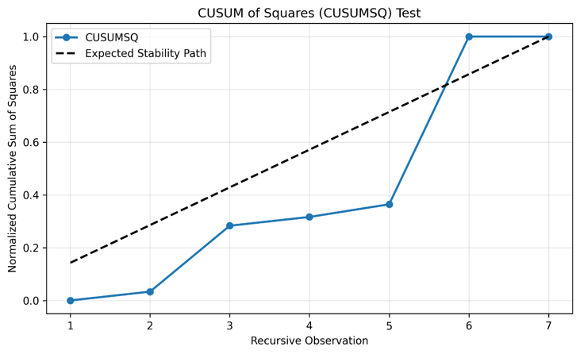
Figure 4: CUSUM of Squares (CUSUMSQ) Test
Above Figure represents the CUSUMSQ test for variance stability. The plot shows slight departures from the expected stability line, suggesting some degree of parameter instability, though this finding should be interpreted with caution because the test is based on a relatively small sample size.
Table 11: Residual Autocorrelation and Heteroskedasticity Diagnostic Tests
Test | Statistic | p-value | Decision | Interpretation
Durbin–Watson | 2.396 | – | Accept | No evidence of first-order autocorrelation.
Ljung–Box (Lag 1) | 1.091 | 0.296 | Fail to reject H₀ | No autocorrelation at lag 1.
Ljung–Box (Lag 2) | 1.353 | 0.508 | Fail to reject H₀ | No autocorrelation up to lag 2.
ARCH-LM | 2.797 | 0.247 | Fail to reject H₀ | No ARCH effects (no conditional heteroskedasticity).

The residual diagnostic tests indicate that all assumptions of the regression model are satisfied. The Durbin–Watson statistic of 2.396 explain the absence of first-order autocorrelation while, the Ljung–Box test results at lags 1 (p = 0.296) and 2 (p = 0.508) confirm that there is no significant serial correlation. Moreover, the ARCH-LM test (Statistic = 2.797, p = 0.247) indicates that, absence of conditional heteroskedasticity. These results support the reliability of the estimated coefficients and the validity of the model's statistical inferences.

5. Discussion
The empirical findings of this study offer a multi-layered understanding of how digital transformation interacts with entrepreneurial development in Nepal, revealing a relationship that is far more complex than simple theoretical predictions. The results paint a picture of digital transformation as an integrated, systemic phenomenon rather than a collection of isolated technological upgrades which is powerfully demonstrated by the PCA results, where four distinct digital infrastructure indicator that are: internet users, fixed broadband subscriptions, mobile cellular subscriptions, and secure internet servers load cohesively onto a single principal component that captures 81.9 percent of the total variance. This statistical coherence validates the theoretical perspective that digitalization progresses as an interconnected ecosystem where advancements in one domain reinforce and enable developments in others, justifying the construction of a composite DTI as a more meaningful measure than any single indicator in isolation.
The absence of a statistically significant short-run relationship between annual changes in DTI and NBD (β₁ = 0.1115, p = 0.480) challenges the assumption that digital infrastructure investments yield immediate entrepreneurial dividends. This finding invites deeper reflection on the temporal dynamics of technology induced entrepreneurial transformation. Several interconnected factors likely explain this temporal lag. First, the adoption of digital technologies for entrepreneurial purposes is inherently non-instantaneous as it needs a gradual process of learning, experimentation, and adaptation through which entrepreneurs develop the requisite digital competencies, cultivate trust in digital platforms, and embed technology into their business models in ways that meaningfully generate value (Goldfarb & Tucker, 2019).Second, the causal pathway from digital infrastructure to entrepreneurship operates through multiple intermediary channels which improved information flows, reduced transaction costs, enhanced market connectivity, and expanded financial inclusion. Each of these requires time to mature and become effective (Autio et al., 2018). Third, and perhaps most critically, the translation of digital opportunities into entrepreneurial action is contingent upon a broader enabling environment. The persistence of institutional constraints in Nepal including limited access to formal credit, regulatory burdens, weak digital trust mechanisms, and the absence of comprehensive digital literacy programs may substantially attenuate the immediate effects of digital infrastructure improvements, meaning that connectivity alone cannot overcome structural barriers to entrepreneurship (World Bank, 2016).
The ARDL bounds test suggests the existence of the potential long-run equilibrium, combined with the UECM results statistically significant long-run DTI coefficient (0.3555, p=0.006) and statistically significant error correction term (-1.6194, p=0.005) provide grounds for the positive but reserved conclusion. These results implies that although there might not be any quick results from digital transformation but there is evidence that it plays an important role in entrepreneurial development in the long run due to gradual transformation processes caused by digitalization that include reduction of information asymmetry, barriers to enter the market, knowledge spillovers, and network effects (Aker & Mbiti, 2010; Acs et al., 2012). The significance of the error correction term suggests that the system tends to move back to its long-run equilibrium position. However, the absence of Granger causality in either direction complicates this narrative, implying that the relationship between digital transformation and entrepreneurship is not characterized by simple unidirectional or bidirectional causal flows, but rather operates through complex, mutually reinforcing feedback loops where both variables are influenced by common underlying factors such as economic development, human capital accumulation, institutional evolution, and broader ecosystem dynamics (Sussan & Acs, 2017).
However, despite limitations due to sample size in terms of moderation analysis, the insights from the analysis of macroeconomic variables as possible moderators provide some insight into the importance of the overall economic context. The high level of correlation between the domestic credit and NBD (r = 0.93) underscores the critical importance of financial sector development in facilitating entrepreneurial activity which suggest that even the most advanced digital infrastructure may have limited impact on business creation if entrepreneurs lack access to the financial resources necessary to capitalize on digital opportunities. This finding aligns with extensive literature demonstrating that financial constraints represent one of the most significant barriers to entrepreneurship in developing countries (Beck et al., 2018; Brixiová et al., 2020). In turn, the low negative correlation between GDP growth and NBD (r = -0.05) presents a counterintuitive pattern and can be explained by specific features of economic growth in Nepal, which has been heavily driven by remittances and consumption rather than productive investment and business creation. The moderate correlation between FDI and NBD (r = 0.44) indicates that FDI serves as a complement and not a major factor. it may generate technological spillovers as well as backward linkages which would help in creating business activity locally, though its relative weakness compared to domestic credit suggests that internal financial conditions are more critical determinants of entrepreneurial activity.
These results resonate strongly with the KSTE as well as the broader literature on technology and development that emphasize that digital infrastructure constitutes a necessary but insufficient condition for entrepreneurial development in developing countries (Acs et al., 2012; World Bank, 2016; Nambisan, 2017). The findings are in agreement with previous researches that showed have found weak or mixed effects of ICT on entrepreneurship in contexts where complementary conditions are not well developed (Dvouletý et al., 2016) , showing the lack of success of Nepal in terms of digital literacy, financial inclusion, institutional quality, regulatory capacity and the rest can explain the absence of statistically significant short-term effect of digitalization on entrepreneurship. The divergence between short-run and long-run outcomes clearly shows the importance of the difference between temporary shocks and structural changes as yearly fluctuations in the levels of digitalization cannot reveal the process of accumulation of digital capacity, network effects and institutional adaptation characteristic of digital transformation.
The small effective sample size is a significant limitation that warrants careful consideration. particularly for the ARDL model where the need for lags and missing values reduced observations to only eleven annual data points. This constraint substantially limits statistical power, making it difficult to distinguish between the true absence of effects and the inability to detect existing effects due to limited observations. Consequently, the results should be interpreted with appropriate caution, as evidence from a time-series study conducted within the constraints of data availability for Nepal rather than conclusive proof of the absence of relationships. The small sample also prevented explicit testing of interaction effects between DTI and macroeconomic variables, leaving the moderation hypothesis partially unexplored and suggesting that future research with larger samples, possibly employing provincial or firm-level panel data which could provide more definitive evidence on these important questions.

6. Conclusion, Limitations, and Policy Implications
6.1 Conclusion
This study examined whether digital transformation has contributed to entrepreneurial development in Nepal during the period 2006–2024. A composite DTI was constructed using Principal Component Analysis based on internet users, broadband subscriptions, mobile cellular subscriptions, and secure onternet servers. The empirical analysis employed a first-differenced regression model as the primary estimation approach, supported by ARDL estimation, bounds testing, Error Correction modeling, Granger causality tests, and a comprehensive set of diagnostic tests to examine both short-run and long-run relationships, as well as the potential moderating role of macroeconomic variables.
digital transformation has a positive and significant effect on entrepreneurial development in Nepal the empirical findings provide only partial and qualified support. In the short run, the first-differenced regression model shows a positive coefficient for DTI (β₁ = 0.1115), but this relationship is not statistically significant (p = 0.480), indicating that annual changes in digital transformation do not immediately translate into changes in New Business Density. The model explains only 1.0% of the variance in entrepreneurial activity which suggest that other factors beyond digital infrastructure play a more dominant role in determining short-run entrepreneurial outcomes. However, the ARDL bounds test provides evidence of a possible long-run equilibrium relationship (F-statistic = 9.692 > upper bound 4.812), with the UECM revealing a statistically significant long-run coefficient for DTI (0.3555, p = 0.006) and a negative, significant error correction term (-1.6194, p = 0.005). This suggests that while digital transformation does eventually contribute to entrepreneurial development through gradual structural changes, the effect is not immediate and requires time to materialize through mechanisms such as reduced information asymmetries, lower market entry barriers, knowledge spillovers, and network effects. The hypothesis is therefore partially supported for the long run but not for the short run.
macroeconomic variables have a significant moderation effect on the relationship between digital transformation and entrepreneurial development the findings provide suggestive rather than definitive evidence. While formal interaction tests could not be conducted due to sample size constraints, the correlation patterns offer important insights. Domestic credit exhibits a remarkably strong positive correlation with NBD (r = 0.93) which suggest that financial sector development plays a crucial enabling role in translating digital opportunities into entrepreneurial action. The high VIF for domestic credit (56.50) indicates its close association with both digital transformation and entrepreneurship, pointing toward an intertwined developmental process. FDI shows a moderate positive correlation (r = 0.44) which denotes a complementary but less dominant role. In contrast, GDP growth shows a weak negative correlation (r = -0.05), likely reflecting Nepal's remittance-driven growth pattern that does not necessarily stimulate productive investment and business creation. These patterns suggest that macroeconomic factors particularly domestic credit availability and moderate the digital-entrepreneurship relationship, but the lack of explicit interaction testing means hypothesis cannot be conclusively confirmed and for greater output which warrants further investigation with larger samples.
Digital transformation has different short-run and long-run impacts on entrepreneurial development as these findings provide strong support. The empirical evidence clearly demonstrates a divergence between short-run and long-run dynamics. In the short run, the first-differenced model shows no significant relationship (p = 0.480), with the model explaining only 1.0% of the variance in NBD. This suggests that year-to-year fluctuations in digital infrastructure do not produce immediate entrepreneurial responses clearly due to time lags in technology adoption, the need for complementary factors such as digital skills and institutional quality, and the gradual nature of structural transformation. In contrast, the long-run analysis reveals a statistically significant relationship, with the ARDL bounds test indicating cointegration and the UECM showing a significant long-run coefficient. The negative, significant error correction term (-1.6194, p = 0.005) indicates that the system adjusts toward long-run equilibrium, meaning that while digital transformation's entrepreneurial benefits are delayed, as they are not illusory. This divergence underscores the importance of distinguishing between temporary fluctuations and structural transformations, as annual variations in digital indicators may not capture the gradual accumulation of digital capabilities, network effects, and institutional adaptation that characterize genuine digital transformation. The Granger causality results show no significant causal relationship in either direction, further complicate the narrative, that suggest the relationship operates through complex, mutually reinforcing feedback loops rather than simple causal flows. Thu, from a policy perspective, The findings imply that expansion of digital infrastructure alone is insufficient to promote entrepreneurial growth.
6.2 Limitations
There are five major limitations in this study that could be addressed in future research. First, the study employs annual time-series data from a single country, leading to a limited number of observations. Although the dataset spans the period 2006–2024, the effective sample size was substantially reduced due to missing values and the need for lags in the ARDL model which became obstacle for the long run. This small sample size significantly limits observations and this also prevented the use of more sophisticated estimation techniques, such as quantile regression, threshold models, or more complex interaction specifications, which could have provided richer insights into the research questions. Second, the DTI constructed in this study primarily captures infrastructure-related aspects of digitalization, including internet usage, broadband subscriptions, mobile cellular subscriptions, and secure internet servers. However, it does not account for other critical dimensions of digital transformation, such as digital literacy and skills, digital entrepreneurship capabilities, e-commerce adoption rates, the quality of digital institutions, digital financial inclusion, or the broader digital ecosystem so it cannot capture full scope of digitalization's potential impact on entrepreneurship .Third, the study examines indicators at the national level, which makes it impossible to examine regional, district, or firm-level differences. Fourth, the study does not explicitly model the interaction between digital transformation and macroeconomic variables due to sample size constraints, limiting the ability to formally test the moderation hypothesis and Fifth, this study relies on secondary data from the World Bank's World Development Indicators and Entrepreneurship Database, which may have limitations in terms of data quality, coverage, and consistency over time. Official statistics in developing countries often face challenges related to data collection methodologies, reporting standards, and coverage gaps, this may affect the reliability of the empirical findings.
6.3 Policy Implications
Based on our findings, policymakers should take a well-rounded approach to boost digital entrepreneurship. Simply providing internet access is not enough, so they must also invest in digital skills training, make it easier for small businesses to get loans, and create fair and simple rules. It is important to teach digital skills in schools, job training programs, and business courses, especially for people living in rural and underserved areas, so no one will left behind. At the same time, governments should support mobile banking and online payment services, and also need to set up special loan programs for small and medium businesses, since having access to money is strongly linked to starting new ventures. In order to facilitate entrepreneurs, the government needs to ease registration processes and minimize paperwork, strengthen laws and regulations about online security and privacy, and provide government services through the internet in order to reduce both time and expenses involved. Additionally, establishing innovation centers, collaboration spaces, and business incubation centers may facilitate cooperation among businessmen, scientists, IT professionals, and banking institutions in sharing knowledge and providing mutual support. At the same time, it is necessary to invest into increasing the speed and reliability of the internet, expansion of broadband into villages, and development of cybersecurity measures that will improve user experience and increase user trust. It is very important that policymakers have enough patience and a long-term perspective on the issue as the results of digital development will take time to show themselves and short-term reviews often miss the bigger picture. Therefore, policies should be designed with realistic timelines and a long-term vision to ensure lasting success.

References
Acs, Z. J., Audretsch, D. B., & Lehmann, E. E. (2012). The knowledge spillover theory of entrepreneurship. Small Business Economics, 41(4), 757–774.
Aker, J. C., & Mbiti, I. M. (2010). Mobile phones and economic development in Africa. Journal of Economic Perspectives, 24(3), 207–232.
Autio, E., Nambisan, S., Thomas, L. D. W., & Wright, M. (2018). Digital affordances, spatial affordances, and the genesis of entrepreneurial ecosystems. Strategic Entrepreneurship Journal, 12(1), 72–95.
Beck, T., Demirgüç-Kunt, A., & Levine, R. (2018). Finance and entrepreneurship. In The Oxford Handbook of Entrepreneurship. Oxford University Press.
Brixiová, Z., Kangoye, T., & Yogo, T. U. (2020). Access to finance among small and medium-sized enterprises and job creation in Africa. Structural Change and Economic Dynamics, 55, 177–189.
Cardona, M., Kretschmer, T., & Strobel, T. (2013). ICT and productivity: Conclusions from the empirical literature. Information Economics and Policy, 25(3), 109–125.
Dvouletý, O., Mareš, J., & Pöschl, J. (2016). Does broadband internet access affect entrepreneurial activity? Evidence from European regions. Technological Forecasting and Social Change, 109, 14–25.
Goldfarb, A., & Tucker, C. (2019). Digital economics. Journal of Economic Literature, 57(1), 3–43.
Pandey, B., & Taufique, K. M. R. (2022). Digital literacy and entrepreneurial intentions in Nepal. Journal of Entrepreneurship in Emerging Economies, 14(3), 456–475.
Pesaran, M. H., Shin, Y., & Smith, R. J. (2001). Bounds testing approaches to the analysis of level relationships. Journal of Applied Econometrics, 16(3), 289–326.
Shrestha, S., & Neupane, R. (2020). Mobile banking and micro-enterprise development in Nepal. Asian Journal of Technology Innovation, 28(2), 189–207.
Nambisan, S. (2017). Digital entrepreneurship: Toward a digital technology perspective of entrepreneurship. Entrepreneurship Theory and Practice, 41(6), 1029–1055.
Ritter, T., & Pedersen, C. L. (2020). Digitization capability and the digitalization of business models in business-to-business firms. Industrial Marketing Management, 86, 180–190.
Sussan, F., & Acs, Z. J. (2017). The digital entrepreneurial ecosystem. Small Business Economics, 49(1), 55–73.
Verhoef, P. C., Broekhuizen, T., Bart, Y., Bhattacharya, A., Dong, J. Q., Fabian, N., & Haenlein, M. (2021). Digital transformation: A multidisciplinary reflection and research agenda. Journal of Business Research, 122, 889–901.
World Bank. (2016). World Development Report 2016: Digital Dividends. World Bank.
DataReportal. (2024). Digital 2024: Nepal. https://datareportal.com/reports/digital-2024-nepal
Department of Information Technology. (2026). Nagarik App: One-stop solution for government services. Government of Nepal. https://nagarik.gov.np
Government of Nepal. (2015). National Information and Communication Technology Policy, 2015. Ministry of Communication and Information Technology.
Government of Nepal. (2015). National Broadband Policy, 2015. Ministry of Communication and Information Technology.
Government of Nepal. (2019). Digital Nepal Framework 2019: Unlocking Nepal's Growth Potential. Ministry of Communication and Information Technology.
Nepal Rastra Bank. (2023). National Payment System Development Strategy. Nepal Rastra Bank.
Nepal Telecommunications Authority. (2025). Rural Telecommunication Development Fund initiatives. Nepal Telecommunications Authority.
APNIC Blog. (2025). Everyone, everywhere, all the time — Nepal's push for rural broadband inclusion. https://blog.apnic.net
East Asia Forum. (2026). Nepal's economy after the Gen Z protest. https://eastasiaforum.org
IMF. (2026). Nepal: 2026 Article IV Consultation. International Monetary Fund.
Kantipur Daily. (2025). Digital infrastructure expansion in Nepal but digital rights stifled.
Nepal Journals Online. (2025). From Policy to Practice: The State of E-Governance in Nepal.
Rising Nepal Daily. (2025). Bridge Digital Gap.
Rising Nepal Daily. (2025). Cyberattacks Expose Cracks In Digital Security.
Rising Nepal Daily. (2025). Digital Nepal—A Dream In Progress.
Spotlight Nepal. (2026). Reimagining Nepal's Economy through Entrepreneurship.
The Annapurna Express. (2025). Beyond payments: Forging Nepal's next digital leap.
The Diplomat. (2026). Nepal's Digital Divide: Why Millions Still Lack Affordable Internet Access.
The Himalayan Times. (2025). Nepal's AI Policy: Digital divide and implementational challenges.
World Bank. (2018). Information and Communications Technology: Sectoral Analysis: Nepal.
World Bank. (2025). Nepal Country Economic Memorandum.
World Economic Forum. (2025). Why Nepal Struggles to Adopt Better Technology.

Appendixes
Appendix A. Descriptive and Trend Statistics
Figure A1. Descriptive statistics of study variables
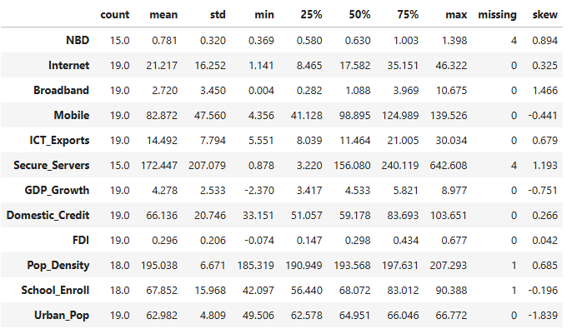

Table A2. WDI study variables
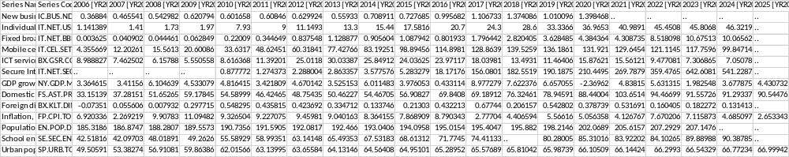

Appendix B. Pre-Estimation Diagnostics
Figure B1. ADF, PP, and KPSS unit root test results (individual variables)
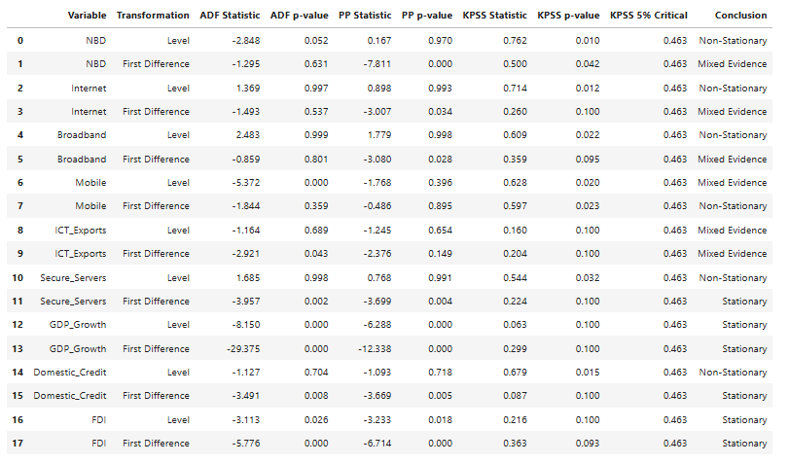
Figure B2. Variance Inflation Factor (VIF) results
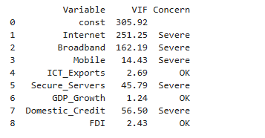
Figure B3. PCA results for the DTI (component loadings, variance explained)
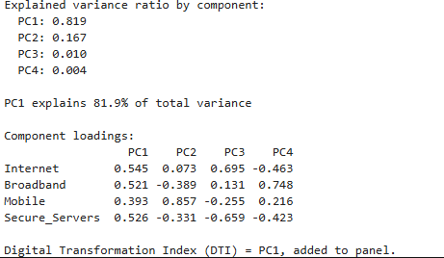
Figure B4. ADF, PP, and KPSS unit root test results for DTI (level and first difference)

Appendix C. Main Estimation Results
Figure C1. First-differenced OLS regression results (ΔNBD on ΔDTI)
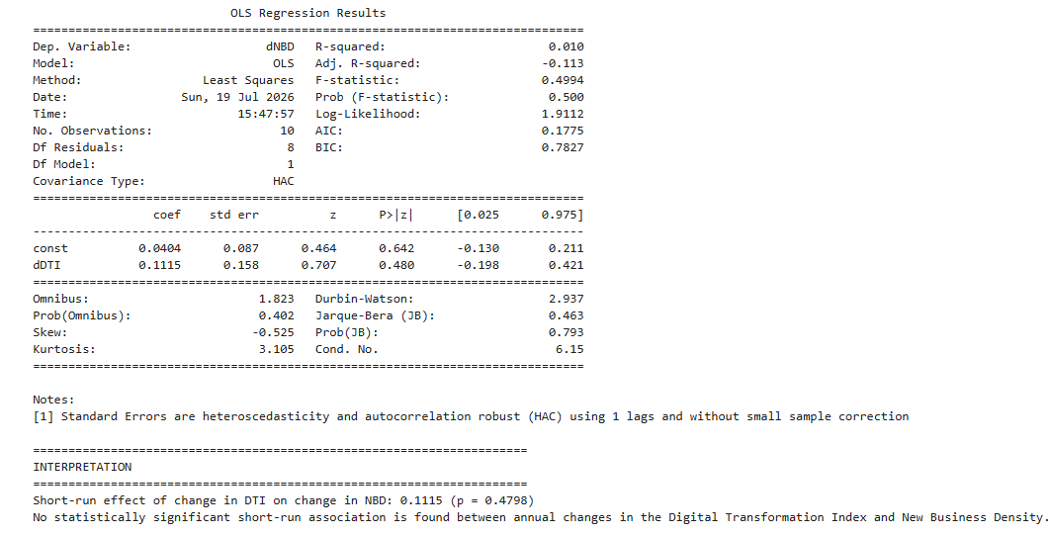

Figure C3. ARDL bounds test results
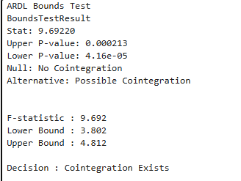
Figure C4. Short-run and long-run UECM coefficients
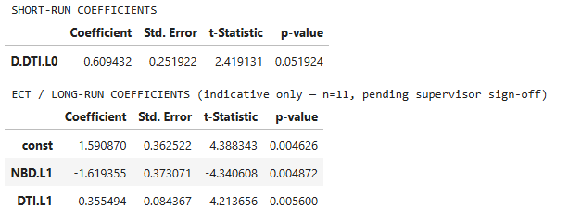
Figure C5. Granger causality test results

Appendix D. Model Diagnostics
Figure D1. Breusch-Godfrey, Jarque-Bera, Breusch-Pagan, and Ramsey RESET test results
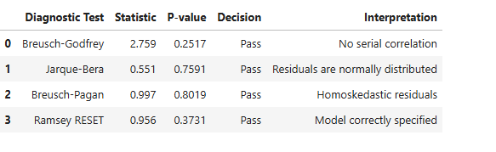

Ms Subedi is a Research Intern at the Innovative Circle, an independent research institute.
Mr. Adhikari is an Assistant Professor of Economics at the Tribhuvan University. He is accessible at adhikarims06@gmail.com or jeebanath.adhikari@rrlc.tu.edu.np. Mr. Adhikari is the corresponding author.

